Module 1 Lesson 3
SELF-DIRECTED LEARNING

Study the chart which shows electrical fatalities from Australia and New Zealand between 2000 and 2017.
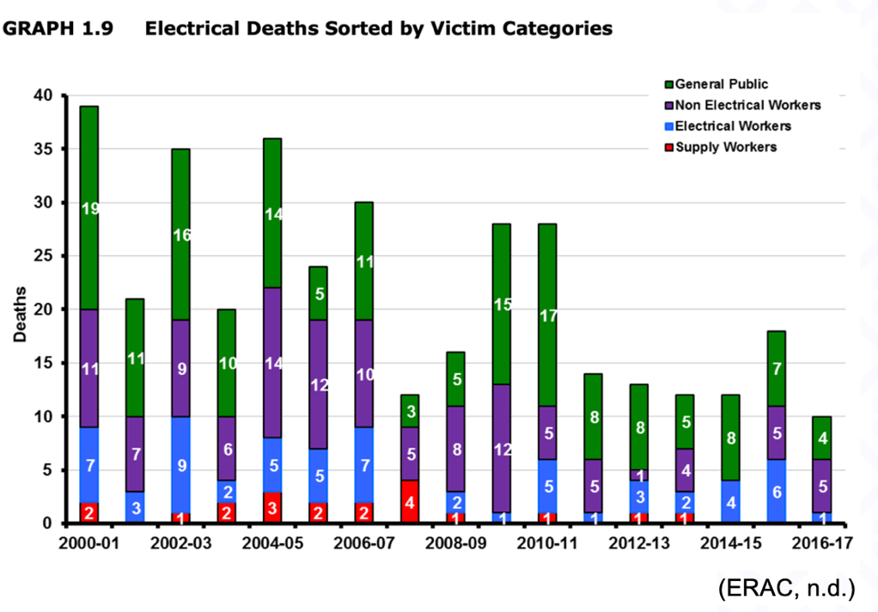

- Comment on the trends for each of the four victim categories during this period and suggest reasons for any trends you have noted. Write your comments in the table below.

General
Public
Non-electrical workers
Electrical workers
Supply workers

- Calculate the percentage each category makes up of the total deaths for the 17 year period.

Category | Calculation | % total deaths
General Public
Non-electrical workers
Electrical workers
Supply workers

- Present your findings in question 2 as a pie chart. (Create on Excel then copy and paste into box.)

